**EDUTEK**

***A Project Report submitted in partial fulfilment of the requirements for the award of the degree of***

**Bachelor of Technology**

**in**

**Computer Science and Engineering**

**(Hons.)**

**by**

**Name of Student: Mansi Sinha**

**Roll No:2115800016**

**Name of Student: Ayush Tiwari**

**Roll No:2115800008**

**Group No:11**

Under the Guidance of

Mr. Saksham Mishra

Department of Computer Engineering & Applications

**Institute of Engineering & Technology**



**GLA University**

**Mathura- 281406, INDIA**

**May 2024**



**Department of computer Engineering and Applications**

**GLA University, Mathura**

**17 km. Stone NH#2, Mathura-Delhi Road, P.O. – Chaumuha,**

**Mathura – 281406**

**Declaration**

I hereby declare that the work which is being presented in the Mini Project “**LMS: Learning Management System”,** in partial fulfillment of the requirements for Mini Project viva voce, is an authentic record of my own work carried under the supervision of “Mr. Saksham sir”

Course: B. Tech Hons CS. (Computer Science and Engineering)

Year: 3rd

Semester: 6th0

Supervised by: Mr. Saksham Mishra



Signature

**ACKNOWLEDGEMENT**

We would like to express our sincere gratitude to everyone who has contributed to the development and success of Edutek, our Learning Management System. First and foremost, we extend our heartfelt appreciation to our dedicated team members whose hard work, expertise, and commitment have been instrumental in bringing this project to fruition. Their tireless efforts in coding, designing, testing, and implementing various functionalities have played a crucial role in shaping Edutek into a robust and user-friendly platform. We also extend our thanks to our valued users whose feedback, suggestions, and engagement have helped us continually improve and refine the platform to better meet their needs. Additionally, we would like to acknowledge the support and guidance provided by our mentors, advisors, and industry experts, whose insights and counsel have been invaluable throughout the development process. Furthermore, we are grateful to the open-source community for their contributions, as well as to the creators of the technologies and tools we have utilized in building Edutek. Last but not least, we express our appreciation to our families, friends, and loved ones for their unwavering support and encouragement throughout this journey. It is with deep gratitude and humility that we acknowledge everyone who has played a part in making Edutek a reality.

**GROUP MEMBERS NAMES:**

Name of Student: Mansi Sinha

University Roll No.:2115800016

Name of Student: Ayush Tiwari

University Roll No.:2115800008

**CONTENTS**

Declaration ii

Certificate ii

Acknowledge iii

Abstract iv

List of figures v

List of Tables vi

**CHAPTER 1 Introduction 1**

1.1 Overview and Motivation 2

1.2 Objective 3

1.3 Summary of Similar Application 4

1.4 Organization of the Project 6

**CHAPTER 2** **Software Requirement Analysis 10**

2.1 Technical Feasibility 11

**CHAPTER 3** **Software Design 35**

3.1 This is the Section

3.1.1 This is a subsection 40

**CHAPTER 4 Implementation and User Interface 48**

**CHAPTER 5 Software Testing 58**

**CHAPTER 6 Conclusion 60**

**CHAPTER 7 Summary 62**

**APPENDICES**

Appendix 1. Example of Description Page

Appendix 2. Sample References

**ABSTRACT**

Edutek represents a paradigm shift in online education, offering a comprehensive and cutting-edge Learning Management System (LMS) designed to meet the evolving needs of learners and educators in the digital age. Built upon a sophisticated technological stack comprising Node.js, Express.js, MongoDB, TypeScript, and Next.js, Edutek seamlessly integrates backend and frontend components to provide a robust, scalable, and user-friendly platform. One of its standout features is the incorporation of DRM-encrypted video content, ensuring the secure delivery of multimedia learning materials while safeguarding against unauthorized access and piracy. Moreover, Edutek boasts a versatile payment gateway infrastructure, allowing users to seamlessly enroll in courses using their preferred method of payment, thereby enhancing accessibility and convenience.

Beyond its technical prowess, Edutek prioritizes user engagement and interactivity through a range of dynamic features. From user authentication and access control mechanisms to real-time communication facilitated by Socket.io, Edutek fosters a collaborative learning environment that promotes active participation and knowledge retention. Furthermore, its intuitive course interaction tools, including question-and-answer forums and review functionalities, empower learners to engage with course content, seek clarification, and provide feedback, thereby enriching the learning experience and fostering a sense of community among users.

In conclusion, Edutek represents a holistic approach to online education, leveraging advanced technologies, user-centric design principles, and robust administrative capabilities to create a dynamic and engaging learning environment. With its emphasis on security, accessibility, and interactivity, Edutek has the potential to redefine the landscape of online learning, making high-quality education accessible to learners worldwide and empowering them to achieve their academic and professional goals.

#### INTRODUCTION

Edutek is an innovative Learning Management System (LMS) designed to revolutionize online education. Leveraging cutting-edge technologies such as Node.js, MongoDB, and Next.js, Edutek offers a seamless and secure learning experience for users. With features like DRM-encrypted video content, multiple payment gateways, and interactive course interactions, Edutek provides a comprehensive platform for both learners and educators. From robust user authentication to comprehensive admin dashboards, Edutek is poised to redefine the landscape of online learning.

* 1. **Overview and Motivation**

Edutek is a groundbreaking Learning Management System (LMS) built on cutting-edge technologies like Node.js, MongoDB, and TypeScript. It aims to revolutionize online education by providing a secure, interactive, and user-friendly platform. Motivated by the need for a modernized and accessible learning experience, Edutek prioritizes features such as DRM encryption for content security, multiple payment gateways for seamless enrollment, and real-time communication tools for enhanced engagement. Its comprehensive admin dashboard enables efficient management and optimization of the platform, catering to the evolving needs of learners and educators in the digital age.

* 1. **Objective**

The EduTek LMS project presents multifaceted challenges, including the implementation of secure DRM encryption for video streaming and the integration of diverse payment gateways with stringent security measures. Crafting a user-friendly dashboard that accommodates real-time notifications for admins without compromising responsiveness poses a design and technical challenge. Moreover, scaling the database to efficiently handle the growing volume of user data, course analytics, and interactions demands strategic planning to maintain optimal performance as the platform expands. These challenges underscore the intricate nature of developing a comprehensive and secure learning management system.

1. **User-Centric Design**: Develop a platform with a user-centric design to ensure ease of use, intuitive navigation, and seamless interaction with course materials for learners of all backgrounds and abilities.
2. **Content Security**: Implement robust security measures, including DRM encryption, to protect course materials from unauthorized access, downloading, or distribution, thereby safeguarding the intellectual property rights of content creators.
3. **Seamless Enrollment Process**: Integrate multiple payment gateways and streamline the enrollment process to provide users with a hassle-free experience when purchasing courses, thereby increasing user satisfaction and conversion rates.
4. **Enhanced Engagement**: Incorporate interactive features such as real-time communication tools, discussion forums, quizzes, and assignments to foster engagement, collaboration, and active learning among learners, leading to improved knowledge retention and course completion rates.
5. **Administrator Empowerment**: Provide administrators with comprehensive dashboards and analytics tools to monitor user activity, track course performance, and manage user accounts effectively. This enables administrators to make data-driven decisions, identify areas for improvement, and enhance the overall effectiveness of the platform.
6. **Scalability and Performance**: Design the platform with scalability in mind to accommodate a growing user base and increasing demand for courses without compromising performance or user experience. Implement efficient database management, caching mechanisms, and optimization techniques to ensure smooth operation even during peak usage periods.
7. **Accessibility and Inclusivity**: Ensure that the platform is accessible to users with disabilities by adhering to accessibility standards and guidelines. Provide alternative formats for course materials, support for assistive technologies, and customizable user interfaces to accommodate diverse learner needs.
8. **Continuous Improvement**: Establish mechanisms for gathering user feedback, conducting usability testing, and iterating on features and functionalities based on user input and emerging trends in online education. This iterative approach ensures that the platform remains relevant, competitive, and aligned with the evolving needs of learners and educators.
   1. **Summary of Similar Application**

**Moodle**: Moodle is an open-source LMS that offers a wide range of features for course management, assessments, collaboration, and analytics. It provides flexibility and customization options, making it popular among educational institutions and corporate training programs.

**Canvas**: Canvas is a cloud-based LMS known for its user-friendly interface and extensive feature set. It provides tools for course creation, grading, communication, and collaboration, catering to the needs of educators and students in various learning environments.

**Blackboard Learn**: Blackboard Learn is a well-established LMS widely used in higher education for its comprehensive suite of tools for course management, content delivery, assessments, and student engagement. It offers educators the resources they need to create dynamic and interactive online learning experiences.

**Google Classroom**: Google Classroom simplifies digital learning with its seamless integration with Google Workspace tools like Google Drive, Docs, and Calendar. It streamlines assignment creation, distribution, and grading, fostering collaboration and communication among teachers and students.

**Schoology**: Schoology is a cloud-based LMS designed specifically for K-12 schools and districts. It offers features such as course management, collaboration tools, assessments, and analytics, empowering educators to create engaging and personalized learning experiences for students.

**D2L Brightspace**: D2L Brightspace provides a customizable learning environment for higher education and K-12 settings. With features like course design, assessment tools, communication tools, and analytics, it supports personalized learning experiences tailored to the needs of students and educators.

* 1. **Organization of the Project**

1. **Project Management**: Establish project goals, timelines, and milestones. Define roles and responsibilities for team members and stakeholders. Use project management tools such as Trello, Asana, or Jira to track progress and manage tasks.
2. **Requirements Gathering**: Collaborate with stakeholders, including educators, administrators, and learners, to gather requirements and define the scope of the project. Document functional and non-functional requirements to guide the development process.
3. **Architecture Design**: Design the architecture of the Edutek platform, including the backend infrastructure, frontend components, database schema, and integration with third-party services such as payment gateways and DRM encryption providers.
4. **Development**: Implement the features and functionalities of the Edutek platform according to the defined requirements and architectural design. Use technologies such as Node.js, Express.js, MongoDB, TypeScript, and Next.js to develop the backend and frontend components.
5. **Testing**: Conduct rigorous testing of the Edutek platform to ensure reliability, security, and usability. Perform unit tests, integration tests, and end-to-end tests to identify and address any bugs or issues.
6. **Deployment**: Deploy the Edutek platform to a production environment, ensuring scalability, performance, and security. Use deployment tools such as Docker, Kubernetes, or AWS Elastic Beanstalk to streamline the deployment process.
7. **Documentation**: Document the architecture, design decisions, development process, and deployment instructions for the Edutek platform. Provide user manuals, API documentation, and troubleshooting guides to support users and administrators.
8. **Training and Support**: Provide training sessions for administrators, educators, and learners on how to use the Edutek platform effectively. Offer ongoing support and assistance to address any questions or issues that arise during use.
9. **Feedback and Iteration**: Gather feedback from users and stakeholders to identify areas for improvement and iterate on the Edutek platform. Continuously update and enhance the platform based on user feedback and emerging trends in online education.
10. **Maintenance and Updates**: Maintain and support the Edutek platform, addressing any bugs, security vulnerabilities, or performance issues that arise. Release regular updates and patches to improve functionality and address user need

**SOFTWARE REQUIREMENT ANALYSIS**

Software Requirement Analysis for the Edutek project involves a comprehensive examination of the needs and expectations of stakeholders, including educators, administrators, and learners, to define the functional and non-functional requirements of the platform. This process includes gathering and documenting requirements through interviews, surveys, and workshops, and analyzing them to ensure clarity, completeness, and feasibility. Key considerations include user authentication and access control, content security through DRM encryption, seamless enrollment via multiple payment gateways, and interactive course features such as real-time communication tools and assessment capabilities. Additionally, scalability, performance, and usability requirements are identified to ensure that the platform can accommodate growing user demand and deliver a seamless learning experience across devices and browsers. Through thorough requirement analysis, the Edutek project aims to establish a solid foundation for the design, development, and implementation of a robust and user-friendly Learning Management System.

#### 2.1 Technical Feasibility

#### 1. Backend Technologies:

**Node.js and Express.js:**

Node.js provides a scalable, event-driven architecture for server-side development, ensuring efficient handling of concurrent requests.

Express.js, as a minimalist web framework for Node.js, streamlines route handling and middleware integration.

**MongoDB:**

MongoDB's flexible document-based data model is well-suited for managing diverse course content and user data.

Its scalability and performance enable seamless handling of large volumes of data.

**RTK Query and Socket.io:**

RTK Query simplifies data fetching and state management, enhancing the efficiency of client-server communication.

Socket.io facilitates real-time, bidirectional communication between clients and servers, enabling interactive features like live notifications and chat.

#### 2. Frontend Technologies:

**TypeScript:**

TypeScript enhances code maintainability and scalability by adding static typing to JavaScript, reducing runtime errors and improving developer productivity.

**Next.js 13:**

Next.js offers server-side rendering and static site generation, optimizing performance and SEO while providing a smooth user experience.

Its built-in features like file-based routing and API routes streamline development and deployment.

#### 3. Additional Technologies:

**Redis:**

Redis serves as a fast, in-memory data store for caching frequently accessed data, improving application performance and scalability.

**Formik and Yup Validation:**

Formik simplifies form management in React applications, providing utilities for form validation, error handling, and submission.

Yap Validation offers robust validation functionality, ensuring data integrity and user input validation in the login process.

**Video Cipher (DRM Encryption):**

Video Cipher's DRM encryption technology secures video content against unauthorized access, preventing downloading, recording, or screenshots.

#### 4. Functionality and Integration:

**User Authentication and Authorization:**

Implements secure login mechanisms with Formik and Yap Validation, ensuring only authorized users access the system.

Utilizes session management and JWT tokens for user authentication and authorization.

**Course Management and Payment Integration:**

Integrates with multiple payment gateways to facilitate seamless course purchases.

Manages course content efficiently using MongoDB, with RTK Query optimizing data fetching and caching.

**Admin Dashboard and Notifications:**

Provides administrators with real-time notifications of user activities and purchases.

Employs Socket.io for live updates and communication between the server and admin dashboard.

#### 5. Security Measures:

**DRM Encryption:**

Video Cipher's DRM encryption ensures content security by preventing unauthorized access, copying, or distribution of video materials.

Implements HTTPS encryption for secure communication between clients and servers, safeguarding sensitive user data.

**SOFTWARE DESIGN**

**3.1 This is the Section**

#### 1. Architecture:

Edutek LMS follows a modern, modular architecture that separates concerns and promotes scalability and maintainability. The system employs a microservices architecture, with distinct modules for user authentication, course management, payment processing, and administrative functions. Each module is designed to be independent, allowing for flexible scaling and easy integration of new features.

**2. User Interface:**

The user interface (UI) of Edutek is designed to be intuitive, responsive, and visually appealing. It adopts a clean and minimalist design language, with emphasis on ease of navigation and accessibility. The UI is divided into different sections for course discovery, user dashboard, administrative functions, and support. Clear and concise labeling and visual cues guide users through various functionalities, ensuring a seamless user experience across devices and screen sizes.

**3. Database Design:**

The database design of Edutek is optimized for performance, scalability, and data integrity. MongoDB, a NoSQL database, is employed for its flexibility and scalability, allowing for efficient storage and retrieval of diverse data types, including course content, user profiles, transactions, and analytics. The database schema is designed to accommodate future expansion and customization, with indexes and sharding strategies implemented to optimize query performance and minimize latency.

**4. Security Measures:**

Security is a paramount consideration in the design of Edutek LMS. The system incorporates multiple layers of security measures to protect user data, content, and transactions. User authentication and authorization are implemented using industry-standard protocols such as JWT (JSON Web Tokens) and OAuth, ensuring secure access to authorized users only. Additionally, sensitive data is encrypted at rest and in transit using strong encryption algorithms, with regular security audits and penetration testing conducted to identify and mitigate potential vulnerabilities.

**5. Integration and Interoperability:**

Edutek LMS is designed to seamlessly integrate with external systems and services, including payment gateways, content delivery networks (CDNs), and third-party APIs. RESTful APIs are employed for interoperability, allowing for easy communication and data exchange between different components of the system. Webhooks and event-driven architecture facilitate real-time integration with external systems, enabling features such as instant notifications and updates.

**6. Scalability and Performance:**

Scalability and performance are key considerations in the design of Edutek LMS, especially given the potential for rapid growth and increasing user demand. The system is designed to be horizontally scalable, with load balancing and auto-scaling mechanisms implemented to handle spikes in traffic and ensure optimal performance under heavy loads. Caching strategies, such as Redis caching, are employed to minimize latency and improve response times, while CDN integration optimizes content delivery for users across the globe.

**3.1.1 This is a subsection**

**Database Design:**

**Schema Design:**

The database design of Edutek LMS is meticulously structured to ensure efficient storage, retrieval, and management of data. It employs MongoDB, a NoSQL database, chosen for its flexibility and scalability. The schema design is optimized to accommodate various data types and relationships inherent in a learning management system.

**Collections and Documents:**

In MongoDB, data is organized into collections, analogous to tables in relational databases, and documents, which represent individual records. Edutek utilizes multiple collections to store different types of data, including:

**Users Collection:** Stores user profiles, authentication credentials, and access permissions.

**Courses Collection:** Contains metadata about each course, including title, description, instructor details, and enrollment information.

**Modules Collection:** Organizes course content into modules, such as lessons, quizzes, and assignments.

**Transactions Collection:** Tracks user transactions, including course purchases, enrollment, and subscription details.

**Indexing and Sharding:**

To optimize query performance and minimize latency, Edutek implements indexing strategies on key fields within each collection. Indexes accelerate data retrieval by allowing the database to quickly locate and access relevant documents. Additionally, sharding techniques are employed to horizontally partition data across multiple servers, distributing the workload and ensuring scalability as the system grows.

**Relationships and References:**

MongoDB supports embedded documents and references to establish relationships between data entities. In Edutek, relationships are established using references to maintain data integrity and facilitate efficient querying. For example:

Each user document may contain references to enrolled courses, facilitating quick access to course details and progress tracking.

Course documents may reference instructor profiles, enabling seamless navigation between course content and instructor information.

**Data Migration and Backup:**

Regular data migration and backup procedures are essential to ensure data integrity and continuity of service. Edutek implements automated backup solutions to regularly snapshot the database and store backups securely offsite. Additionally, data migration scripts are employed to handle schema changes, data transformations, and version upgrades while minimizing downtime and data loss.

**Conclusion:**

The database design of Edutek LMS is a critical component of its overall software architecture, providing the foundation for efficient data storage, retrieval, and management. By leveraging MongoDB's flexible document-based model and implementing indexing, sharding, and data relationship strategies, Edutek ensures optimal performance, scalability, and data integrity, thereby delivering a seamless learning experience for users and administrators alike.

**IMPLEMENTATION AND USER INTERFACE**

### User Authentication:

1. **Registration and Login:**

* Users register for an account providing necessary details.
* Formic and Yap Farm validate user inputs to ensure data integrity and security.
* Upon successful registration, users can log in securely.

### Course Management:

1. **Course Catalog:**

* Users can browse through available courses in the catalog.
* Course details include information like course description, instructor details, and curriculum.

1. **Secure Access:**

* Access to course content is restricted based on purchase.
* When a user purchases a course, they gain access to its full content, including video lectures and materials.
* VideoCipher DRM encryption ensures that videos cannot be downloaded, recorded, or screenshotted.

1. **Payment Integration:**

* Edutek integrates with multiple payment gateways to facilitate course purchases.
* Users can choose their preferred payment method and securely complete transactions.

### Admin Features:

1. **Admin Dashboard:**

* Admins have access to a dashboard providing an overview of user activity and course engagement.
* They receive notifications of new course purchases, user questions, and reviews.

1. **User Management:**

* Admins can manage user accounts, including registration approval and account suspension if necessary.

1. **Course Management:**

* Admins oversee course content and instructor details.
* They can add new courses, update existing ones, or remove outdated content.

1. **Interaction with Users:**

* Admins can respond to user questions and reviews, providing assistance and feedback as needed.

### Security Measures:

1. **DRM Encryption:**

* VideoCipher encrypts video content to prevent unauthorized access, downloading, recording, or screenshots.
* This ensures that course materials are protected from piracy and misuse.

1. **Access Control:**

* Users can only access course content they have purchased, preventing unauthorized access.
* Authentication mechanisms ensure that user data remains secure throughout the platform.

### Future Enhancements:

1. **Enhanced User Experience:**

* Continuous improvement of user interface and experience based on user feedback.
* Implementation of features to enhance engagement and learning outcomes.

1. **Scalability and Performance:**

* Optimization of backend processes and database queries to ensure scalability and performance as user base grows.
* Integration of additional technologies or services to enhance platform capabilities.

1. **Security Enhancements:**

* Regular security audits and updates to protect against emerging threats.
* Implementation of additional security measures to safeguard user data and course content.

UI INTERFACE

**Hero section**

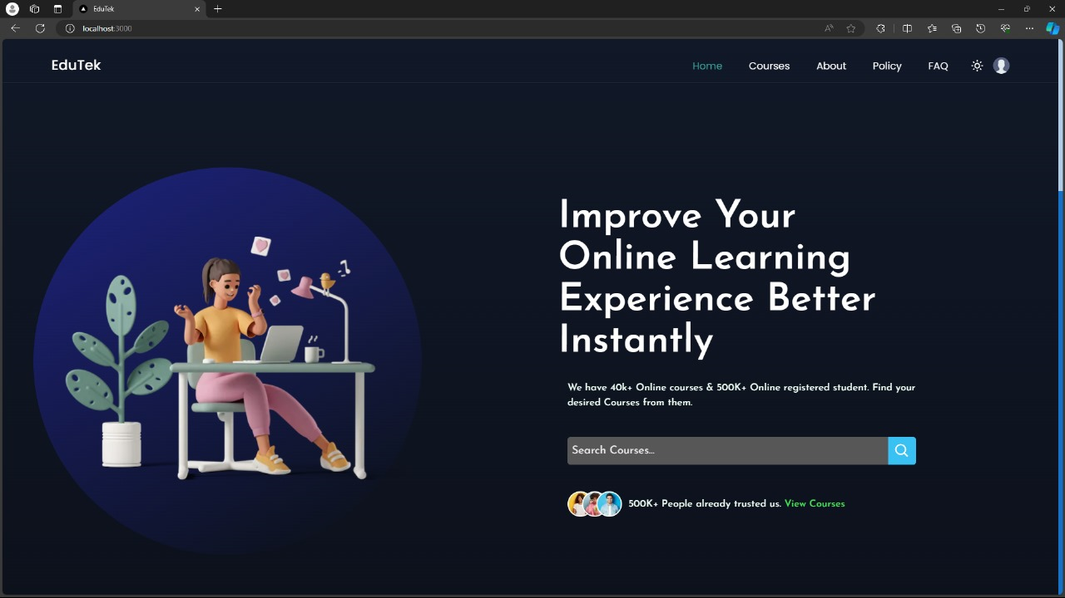

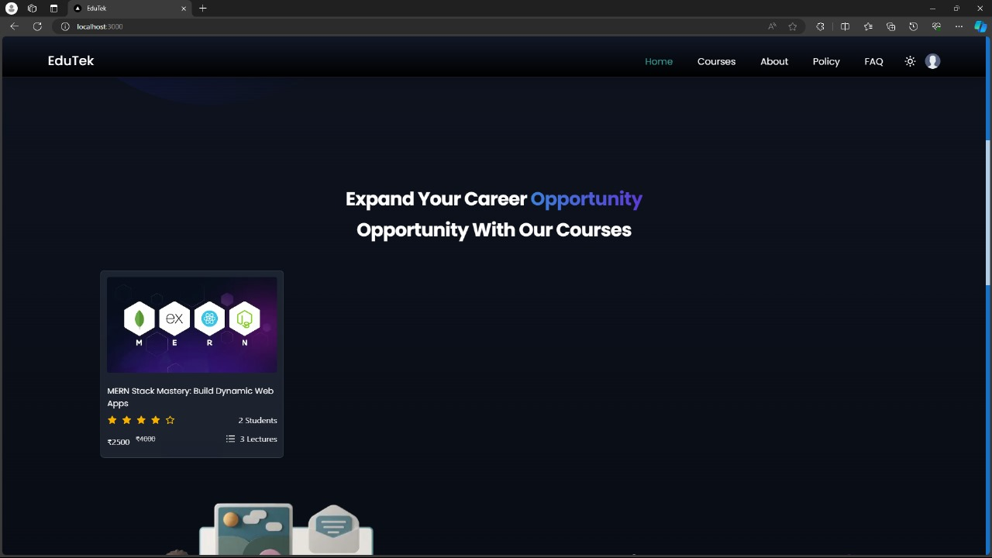

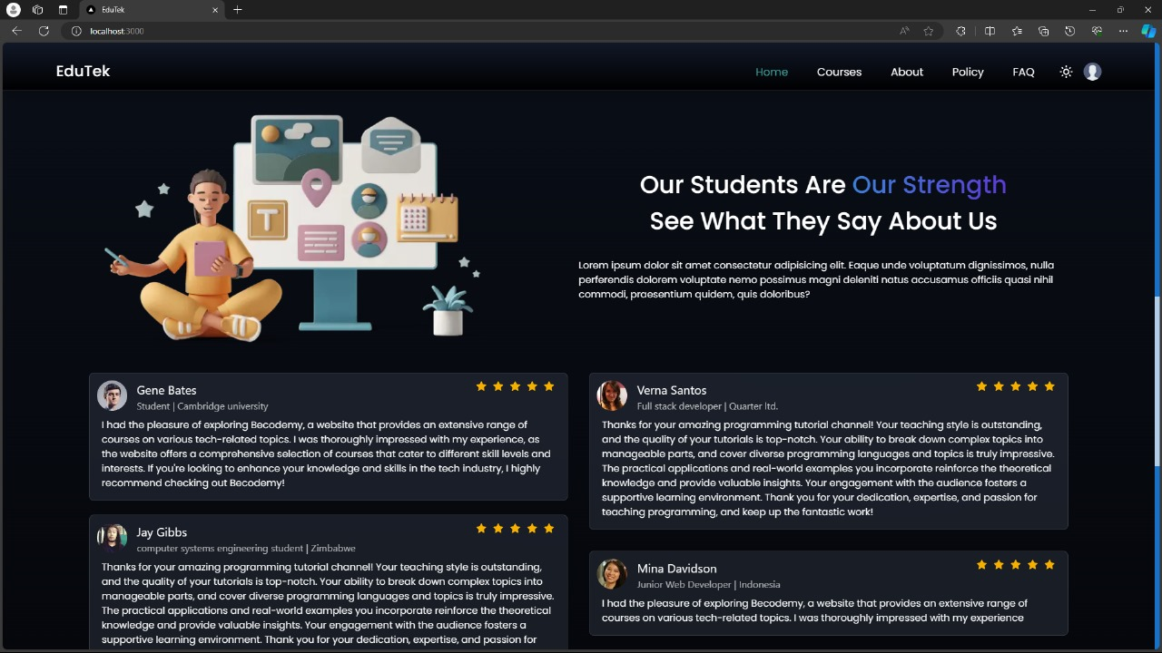

**FAQ section**

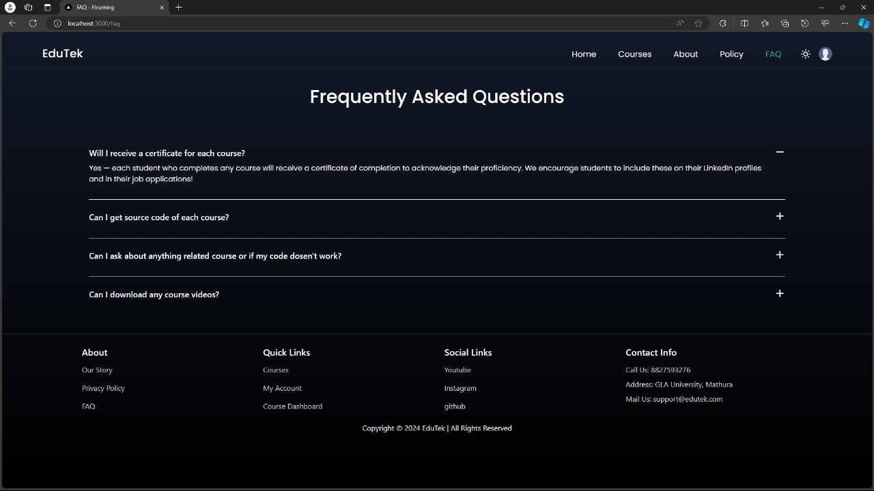

**Courses section**

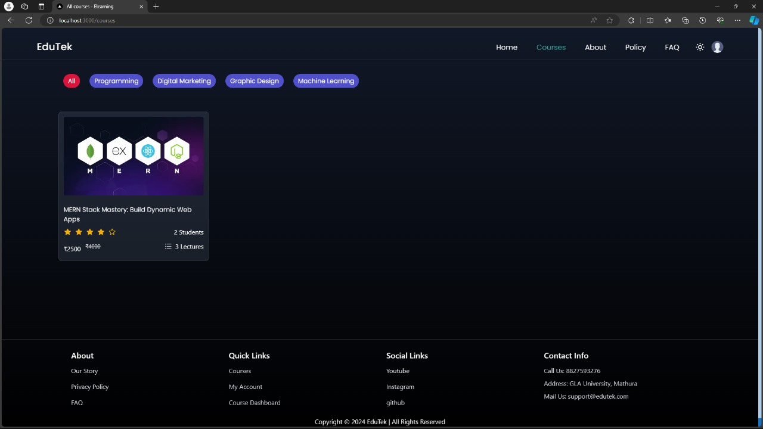

**SOFTWARE TESTING**

#### 1. Testing Approach:

Edutek LMS employs a comprehensive testing approach to ensure the reliability, performance, and security of its software. The testing process encompasses various stages, including unit testing, integration testing, system testing, and acceptance testing.

#### 2. Unit Testing:

Unit testing focuses on testing individual components or modules of the system in isolation. In Edutek LMS, unit tests are written for backend APIs, frontend components, and utility functions using testing frameworks such as Jest for JavaScript and TypeScript. Unit tests verify that each unit of code behaves as expected, detecting and preventing bugs at an early stage of development.

#### 3. Integration Testing:

Integration testing verifies the interactions between different components or modules of the system. In Edutek LMS, integration tests are conducted to ensure seamless communication between frontend and backend components, API endpoints, and external services such as payment gateways and databases. Integration tests validate data flow, error handling, and integration points to identify any inconsistencies or compatibility issues.

#### 4. System Testing:

System testing evaluates the overall functionality and performance of the entire system. In Edutek LMS, system tests simulate real-world user interactions and scenarios to validate core features such as user authentication, course enrollment, content delivery, and administrative functions. System tests cover both functional and non-functional requirements, including usability, accessibility, performance, and security.

#### 5. Acceptance Testing:

Acceptance testing involves validating that the software meets the specified requirements and satisfies user expectations. In Edutek LMS, acceptance tests are conducted by stakeholders, including end-users, administrators, and quality assurance teams, to ensure that the system meets their needs and performs as intended. Acceptance tests encompass user acceptance testing (UAT), usability testing, and exploratory testing to validate user workflows, interface usability, and overall user experience.

#### 6. Security Testing:

Security testing is a critical aspect of software testing in Edutek LMS, given the sensitivity of user data and the potential risks associated with online transactions and content delivery. Security tests are conducted to identify vulnerabilities such as SQL injection, cross-site scripting (XSS), and unauthorized access. Penetration testing, code reviews, and vulnerability assessments are performed regularly to mitigate security risks and ensure compliance with industry standards and regulations.

#### 7. Performance Testing:

Performance testing evaluates the system's responsiveness, scalability, and reliability under various load conditions. In Edutek LMS, performance tests are conducted to measure response times, throughput, and resource utilization during peak usage periods. Load testing, stress testing, and scalability testing are performed to identify performance bottlenecks, optimize system architecture, and ensure smooth operation under heavy user traffic.

#### 8. Regression Testing:

Regression testing is conducted to ensure that new code changes or updates do not introduce unintended side effects or regressions into the system. In Edutek LMS, regression tests are automated using continuous integration (CI) pipelines and executed regularly to validate code changes across different environments. Regression tests cover critical functionalities, edge cases, and integration points to maintain software quality and stability throughout the development lifecycle.

**CONCLUSION**

Edutek Learning Management System represents a culmination of diligent planning, meticulous implementation, and rigorous testing to deliver a sophisticated platform for online education. Throughout the development process, the team has leveraged cutting-edge technologies, thoughtful design principles, and stringent security measures to create a robust and user-friendly learning environment.

From its modular architecture and scalable backend infrastructure to its intuitive user interface and comprehensive feature set, Edutek LMS is poised to revolutionize the way users engage with educational content. By prioritizing user experience, accessibility, and security, the platform offers a seamless learning journey for students while empowering administrators with powerful tools to manage course content, user accounts, and transactions effectively.

The successful implementation of Edutek LMS is a testament to the dedication and expertise of the development team, who have worked tirelessly to bring this project to fruition. Moving forward, the platform will continue to evolve and adapt to the changing needs of learners and educators, incorporating feedback, implementing new features, and staying ahead of technological advancements to remain at the forefront of online education.

With its commitment to excellence, innovation, and lifelong learning, Edutek LMS stands poised to make a meaningful impact in the field of education, empowering individuals around the world to unlock their full potential and pursue their educational aspirations with confidence.

**SUMMARY**

Edutek Learning Management System (LMS) is a comprehensive online platform designed to facilitate seamless and effective education delivery. Built with cutting-edge technologies and meticulous attention to detail, Edutek LMS offers a robust infrastructure for learners, instructors, and administrators alike.

1. **Cutting-Edge Technology:** Edutek Learning Management System (LMS) harnesses modern technologies like Node.js, Express.js, and MongoDB for its backend, ensuring scalability and efficiency. The frontend, developed with TypeScript and Next.js 13, offers an intuitive interface for users.
2. **User-Centric Design:** With a focus on user experience, Edutek LMS provides intuitive features for course discovery, enrollment, and progress tracking. The platform's responsive design ensures accessibility across devices.
3. **Comprehensive Functionality:** Edutek LMS offers a wide range of features, including user authentication, course management, payment integration, and administrative tools. Users can easily browse courses, enroll, and access content, while administrators have full control over course offerings and user accounts.
4. **Security First:** Security is paramount in Edutek LMS, with Video Cipher DRM encryption and HTTPS encryption ensuring data integrity and protection. Robust authentication mechanisms and access controls safeguard sensitive information.
5. **Rigorous Testing:** The project undergoes rigorous testing at every stage, including unit testing, integration testing, system testing, and acceptance testing. Security and performance testing ensure the platform meets high standards of reliability and security.
6. **Revolutionizing Education:** Edutek LMS aims to revolutionize online education by providing a user-centric platform that empowers learners and educators alike. With its powerful features and commitment to quality, Edutek LMS is poised to transform the way individuals engage with educational content.

**REFERENCES**

* [**https://nextjs.org/docs**](https://nextjs.org/docs)
* [**https://nodejs.org/docs/latest/api/**](https://nodejs.org/docs/latest/api/)
* [**https://expressjs.com/**](https://expressjs.com/)
* [**https://www.mongodb.com/docs/**](https://www.mongodb.com/docs/)